Chapter 1

|  |  |  |
| --- | --- | --- |
| Machine Language | Assembly Language | High Level Language |
| * Natural * Defined by hardware design * 0 and 1 * Machine dependent | * English-like abbreviations languages * Assemblers: Translator programs to convert to machine language at computer speeds * > Clearer & easier to understand * Requires many statements * MOV AL, 88h | * To speed programming * Compiler: Convert into machine language * Java |

* Java
* Object-Oriented Programming (OOP): made up of objects to perform actions
* Used to develop Java applet 🡪 executed in Web browser/ applet viewer
* Edit 🡪 Compile 🡪 Load 🡪 Verify & Execute

1. Edit

* With Integrated Development Environment (IDE)
* File end with .java extension
* File name same as Class name

1. Compile

* Translate into byte codes
* Java Platform (JDK 15) provides compiler
* Command: ***javac* filename*.java***
* Syntax: grammar rules (arrangement of words & punctuations)

1. Load

* Class loader take ***.class*** file & translate to memory
* Java applications loaded into memory & executed using Java Interpreter/Virtual Machine/ run-time system

1. Verify

* Byte code verifier ensures byte codes do not violate security requirements

1. Execute

* Interpret program 1 byte code at a time
* Command (java file): ***java* filename**
* Java Achieve (JAR) file created for a java application that consists multiple java files
* Command (jar file): ***java -jar*** **filename*.jar***
* Problem Solving
* Before writing program

1. Have a clear understanding of problem
2. Have a carefully planned approach to solve

* Any computing problem can be solved by executing a series of actions in a **specific order**.
* **Algorithm:** A procedure for solving a problem in terms of the actions to be executed and the order in which actions are to be executed
* General

1. Understand problem. Solve manually with few examples.
2. Devise an algorithm to solve
3. Write program using programming syntax & compile program
4. Correct syntax error after compilation. Save program & compile again.
5. Execute program if error free
6. Test results against expected output.

If results not correct, modify algorithm, rewrite & recompile program.

* Terms

1. **Syntax** – A set of rules, principles, and processes that govern the **structure of statement** in a programming language.
2. **Semantic** – Describe the **meaning** of the things written while following the syntax rules of the language. Semantic describes the things happen when a program is executed.
3. **Debugging** – A process of **eliminating mistakes** in the program. A mistake in a program is called a bug.

* Common bugs/errors

1. **Syntax Error:** A grammatical mistake in the program. A mistake in the arrangement of words and punctuations.
2. **Logic Error:** A mistake in the underlying algorithm or semantic error.
3. **Run-time Error:** An error that happen when the program is executed

* Input Process Output
* Pseudocode: informal high-level description of operating principle of computer program or algorithm
* A numbered list of instructions to perform some task

1. 1 line 1 statement 1 action. Write only 1 statement per line. Each statement express just 1 action.
2. Indent: statement fall inside selection/loop

* Flow Chart: Diagram represents algorithm/process
* Shows steps as various kinds boxes & order by connecting with arrows
* Used in analyzing, designing, documenting or managing a process/ program
* NOTATION

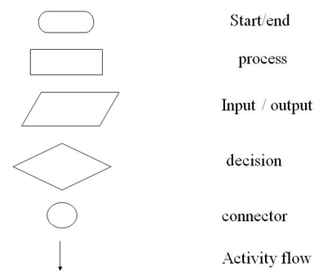

* Sample Java Program
* Consist at least 1 class definition {}
* Contains method main, always static
* ***Void***: method perform task & will not return any info when task completed
* Program >> Classes>> Methods >> Statements
* Case sensitive
* Each statements must end with ;

CHAPTER 2

* Variable: a storage location in memory that has a type, name & contents
* Declared: type & name (identifier: letters + digits, underscore; X spaces/reserved words)
* Primitive types

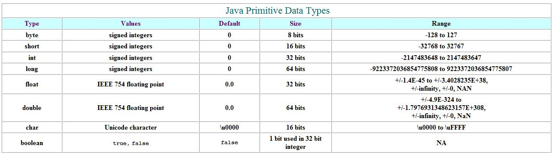

* Constant: ***final* type name = value;**
* Operator: Special symbols perform specific operations on >=1 operands (part of a computer instruction which specifies what data is to be manipulated/operated on)
* Assignment (=): Change value of variable
* 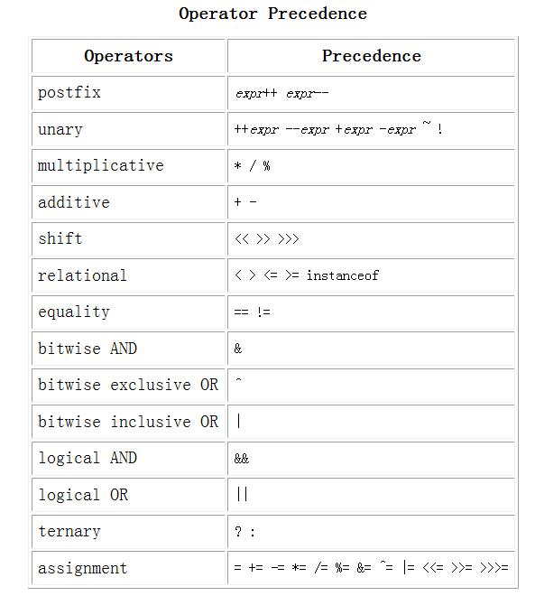Arithmetic

1. + (addition)
2. – (subtraction)
3. * (multiplication)
4. / (division)
5. % (modulo or remainder)

* Parentheses (): controls order
* Postfix: use current value of num, then increment/decrement by 1 for next statement

1. number++;
2. number--;

* Unary: Increment/decrement num by 1 then use the value

1. ++number;
2. –number;

* Other: +=, -=, *= /=, %=

number += a : number = number+a

* Type Casting
* (type) varName
* String

***String*** strName = ***“***value***”***;

* ***+*** concatenate
* Console Input

Import java.util.Scanner;  
***Scanner*** keyboard = ***new Scanner(System.in);***  
varName = keyboard***.nextInt();***

* nextInt(), nextLong(), nextDouble(), next(): 1word, nextLine(): entire line
* Console Output

***System.out.println*** : Output cursor to beginning of next line ***System.out.print***  : X position output cursor at beginning of next line ***System.out.printf*** : specific format (“%6.2f”, varName >> Display 6 spaces with 2 d.p.)

1. \n : newline character
2. \t : horizontal tab
3. \\ : display backslash
4. \” : display double quote

* Comment
* To help other programmers understand program; Not executed

***//***Single Line Comment

***/\****

Multiple line

comments

***\*/***

***/\*\****

This method display a line of text on the screen (documentation describe functionalities of each Java class & methods)

***\*/***

* To run Javadoc on a package:

***Javadoc -d documentationDirectory* PackageName**

* Random Number

Import java.util.Random;

***Random*** name = ***new Random();***

Num = name***.nextInt()***;

* .nextInt(100) : random value from 0 to 99

CHAPTER 3: FLOW OF CONTROL (SELECTION)

1. Sequence Flow: Statement executed one after other in order
2. Selection Flow: Chooses among alternative courses of action
3. Repetition Flow: Specifies an action is to be repeated while some condition remains true

* Relational Operator: Tests relationship between 2 values

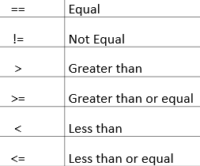

* Logical Operator: Merging multiple constraints/ condition 🡪 Create complex Boolean expression

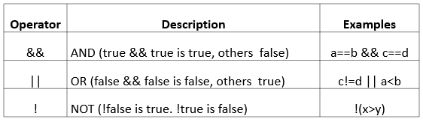

* (Multiway) If-else

***if (*** condition1 ***){*** statement1; ***}  
else if{*** statement2;  
***}  
else{*** statement3; ***}***

* Switch

***switch***( variable )***{***case value1:  
 statement1;  
 ***break;***case value2:  
 statement2;  
 ***break;***  
***default:*** statement3; ***}***

* Ternary Operator

condition1***?*** statement1 ***:*** statement2

* True execute 1, false execute 2
* String Comparison
* Equality

1. s1***.equals***(s2)
2. s1***.equalsIgnoreCase***(s2)

* Alphabetical/Lexicographic order

1. s1.***compareTo***(s2)
2. s1.***compareToIgnoreCase***(s2)

s1 before s2 🡪 -ve || s2 before s1 🡪 +ve || s1==s2 🡪0

CHAPTER 3: FLOW OF CONTROL (REPETITION)

1. Count-controlled loop: Executed statements for fixed number of times
2. Sentinel-controlled loop: Executed statements repeatedly until sentinel encountered

* While: Executes repeatedly, condition controls how often loop executed

***while(*** condition ***){*** statements; ***}***

* Do-while: Executes body at least once & perform condition check after

***do {*** statements; ***} while(*** condition ***);***

* For: Count-controlled loops; Step through some int var in equal increments/decrements

***for (initialization; condition; update){*** statements; ***}***

* ***break;*** : endsnearest enclosing loop statement
* ***continue;*** : skip remaining statement (ends current loop body iteration of nearest enclosing loop statement) & proceeds with next iteration
* label: label a loop statement, used by the break & continue statement

***stop: {*** //label statement

***…***

***break stop;*** //break the stop label statement

***}***

CHAPTER 5: ARRAY

* Sequence of same type values
* Data structure to process a collection of same type data
* A group of contiguous memory locations that all have the same name & type
* Ordered list of values, each with numeric index (subscript)
* Array size N indexed from 0 to N-1
* A reference data type
* ***new*** operator to construct

|  |  |
| --- | --- |
| Declaration | type***[]*** name ***= new*** type***[length];***   * Default: 0(numeric), false(Boolean), null(references/ string) |
| Initialization | type***[]*** name *=* ***{***value1, value2***};*** |
| Length | name***.length*** |
| To access | name***[indexNo.]*** |
| To display element | ***for(***int i=0; i<name.length; i++***){*** System.out.println(name***[i]***); ***}***  ***for(***int value ***:*** name***){*** System.out.println(***value***); ***}*** //can’t modify value |
| Multidimensional  (Initialization) | type ***[][]*** name = ***new*** type ***[***no.OfRows***][***no.OfColumns***]***  type ***[][]*** name = ***{ { , } , { , } }*** |
| Ragged Arrays  (diff rows diff columns) | type ***[][]*** name = ***new*** type [3][];  t[0] = ***new*** type[3];  t[1] = ***new*** type[10];  t[2] = ***new*** type[5]; |

Bubble Sort

* Uses nested loop to make several passes, each pass compares successive pairs
* If pair increasing order, leaves value as they are; If pair decreasing order, swaps values in array

*//control number of passes*

*for( int pass = 1; pass<b.length; pass++){  
 //control number of comparison  
 for( int i = 0; i<b.length-1; i++){  
 if (b[i] = b[i+1]){  
 int hold = b[i];  
 b[i] = b[i+1];  
 b[i+1] = hold;  
}*

* Linear Search: Small/unsorted arrays

for (int cnt = 0; cnt<name.length; cnt++){  
 if( name[cnt] == searchKey ){  
 return cnt;  
return -1; //key not found

}

Binary Search

CHAPTER 6: METHODS

* Modules = Methods = Classes : Allow programmer to modularize program
* Local variable: a variable declared within a method
* Call-by-value method invocation: When invoke a method, a copy of the value of each actual parameter is passed to the method; Any changes to the copy inside method have no effect on actual parameter
* Reference type(Object & array): Any changes to instance variable will have effect on actual parameter; constant ***null*** indicate no real value
* Comment types

1. Precondition: states what is assumed to be true when method is called
2. Postcondition: describes effect of method call, describes value returned by method

* Define

***accessSpecifier returnType methodName (parameterType parameterName, …) {}***

* accessSpecifier: public; void: return nothing
* Static Method: do not require an calling object

***public static returnType methodName( parameterType parameter, …)***

* To invoke in same class: ***methodName***
* To invoke in different class: ***className.methodName***

LAB

* Generate random integer, range is 10 to 50 (include 50)

int x = random.nextInt(41)+10;

- random.nextInt(n) : 0 <= x < n

- random.nextInt(n)+1 : 1 <= x <=6

roll = (int) (Math.random() * 6 + 1);

* Convert seconds to hr min sec

hr = inputSec/3600;

min = (inputSec % 3600) / 60;

sec = inputSec % 60;

* To sum all digits

|  |
| --- |
| while(num>0){ |
|  | digit = num%10; //this gets the last digit |
|  | sum = sum + digit; |
|  | num = num/10; //this removes the last digit |
|  | } |

* Don't use import java.util.* because the file will become very large (be specific)
* Determine point outside/inside circle

double h = x*x;

double v = y*y;

double l = Math.sqrt(h + v);

if(l > radius){ //outside

<LAB 4>

* **Factors** of an integer

for (int j=1; j<=integer; j++){

if (integer % j == 0) {

System.out.print(j + ", "); }}

* 1 + (1+2) + (1+2+3) + … + (1+2+3+…+n)

for (int x = 1; x<=num; x++){

int result2 = 0;

for(int y=1; y<=x; y++){

result2 += y;

}

result1 += result2;

}

Or

for (int i = 1; i <= n; i++) {

for (int j = 1; j <= i; j++) {

sum += j;

}

}

* Leap Year

(year % 400 == 0) || (year % 100 != 0) && (year % 4 == 0)

* Dice game

boolean isP1Turn = true;

while(Math.max(p1Score,p2Score)<=100){

roll = (int)(Math.random()*(6)+1);

//roll 6 get 6 points and can roll again

if(roll == 6){

bonus = (int)(Math.random()*(6)+1);}

//To store marks for each players

if(isP1Turn){ p1Score += roll + bonus; } else {p2Score += roll + bonus;}

//To take turns

isP1Turn = !isP1Turn; }

* Math.random() function returns **a floating-point, pseudo-random number that's greater than or equal to 0 and less than 1**,
* Calculate number of digits

int counter = (int) Math.log10(randomNum); //result= counter+1

* System.out.printf

%.2f : 2 decimal place

%23s or %23.2f or %23.2s or %23f: 23 spaces before print

* Print n prime numbers

while (ni < n) {   
  
 boolean isPrime = true;

//Check Prime  
 for (int j = 2; j < thisNum; j++) {  
  
 if (thisNum % j == 0) {  
 isPrime = false;  
 break;  
 }  
 }

if(isPrime) { //print

ni++;

}

thisNum++; //Initial = 2

* To arrange array in reverse order

int[] revArr = new int[array.length];

for(int j = 0; j < array.length; j++){

revArr[array.length - 1 - j] = array[j];

}

static void reverse(int[] array) {  
  
 int n = array.length;  
  
 System.*out*.println("Array in descending order");  
#  
 Arrays.*sort*(array);  
  
 for (int j = 0; j < n / 2; j++) {  
 int temp = array[j];  
 array[j] = array[(n - 1) - j];  
 array[(n - 1) - j] = temp;  
 }  
#  
 System.*out*.println(Arrays.*toString*(array));  
}

* Linear Search

static void linearSearch(int[] array, int n) {  
  
 int loopCount = 0;  
#  
 for (int i: array) {  
 if (i == n) { break; }  
 loopCount++;  
 }  
#  
 if (loopCount < array.length) {  
 System.*out*.printf("%d found\nLinear Search - %d loop(s)\n", n, loopCount);  
 }else{  
 System.*out*.println("Not found");  
 }  
}

* Binary Search

static void binarySearch(int[] array, int n) {  
 int low = 0, high = array.length-1, mid = 0, loop=0;  
 while (low < high){  
 mid = (low + high)/2;  
 if( n == array[mid]){System.*out*.println(mid);}  
 else if( n > array[mid]){low = mid+1; } //n is on right side  
 else {high = mid -1;} //n is on left side  
 loop++;  
 }  
 if(mid == n){  
 System.*out*.println("Binary Search - "+loop+" loop(s)");}  
 else{System.*out*.println("Not found");}

LAB 6

* Print 20 Triangular Number

for (int j = 1; j <= 20; j++) {  
 curTriangleNumber += j;  
  
 System.*out*.println(curTriangleNumber);  
}

* Reverse string

static void reverseStr(String str){

char[] arr = str.toCharArray();

for(int i = arr.length-1; i>=0; i--){

System.out.print(arr[i]);

}

}

* Euclidean Algorithm (GCD: Greatest Common Divisor)

// How GCD(200,625) autochange to GCD(625, 200)? Refer IDE to ask

public static int GCD(int a, int b){

if (b == 0) {return a;}

else {return GCD(b, a%b);}

};

Or

public static void GCD(int a, int b){

//if a>b, a=x , if a<b, b=x

int x, y;

if (a>b){

x = a; y = b;

} else {

x = b; y = a;

}

// x is always greater than y

int r1 = y, r2 = x%y;

while (r2 != 0){

int hold = r2;

r2 = r1%r2;

r1 = hold;

}

System.out.println(r1);

}

* Palindromic Prime & Emirp
* Palindromic Prime: Palindromice + Prime

public static boolean isPalinPrime(int arg) {  
 return isPalin(arg) && isPrime(arg);  
 }

* Emirp: Prime(ori) + Prime(reverse) + !PalinPrime

public static boolean isEmirp(int arg) {  
 int reverse = 0;  
 int argCopy = arg;  
  
 while(argCopy > 0){  
 reverse = reverse * 10 + argCopy % 10;  
 argCopy = argCopy / 10;  
 }  
 if (Integer.toString(arg).length() != Integer.toString(reverse).length()){  
 return false;  
 }  
 //System.out.printf("%d %d\n", arg, reverse);  
 return isPrime(arg) && isPrime(reverse) && !isPalinPrime(arg);  
 }

* Palindromic: aba 🡪 reflect 🡪 aba

public static boolean isPalin(int arg) {  
 int argCopy = arg;  
 int reverse = 0;  
  
 while(arg > 0){  
 reverse = reverse * 10 + arg % 10;  
 arg /= 10;  
 }  
  
 return (argCopy == reverse);  
 }

* Prime

public static boolean isPrime(int arg) {  
 for (int i = 2 ; i <= Math.sqrt(arg) ; i++){  
 if (arg % i == 0)  
 return false;  
 }  
 return true;  
 }

* Take char as input

char c = input.next().charAt(0);

* To print shape with repeated character
* Multiprint to print spaces ‘ ’

static void multiPrint(int n, char c){

for (int i=1;i<n;i++)

System.out.print(c);

}

* Multiprint with spaces to print char for shape

static void multiPrintWithSpaces(int n, char c){

for (int i=1;i<n;i++)

System.out.print(c + " ");

}

* Triangle

static void triangle(int n, char c){

for(int i=1;i<=n;i++){ // loop to iterate for the given number of rows

multiPrint(n-i+1, ' ');

multiPrintWithSpaces(i, c);

System.out.println();

}

}

* Diamond

static void diamond(int n, char c){

//Triangle: for upper

// + another for loop: for lower

for (int i=1; i<n;i++){

multiPrint(i + 1, ' ');

multiPrintWithSpaces(n-i, c);

System.out.println();

}

* Generate non-duplicate random number – ArrayList

ArrayList<Integer> randomNum = new ArrayList<Integer>(10);  
  
for (int i = 0; i < 10; i++) {  
 int integer = (int) (Math.*random*() * 21);  
  
 while (randomNum.contains(integer)) {  
 integer = (int) (Math.*random*() * 21);  
 }  
  
 System.*out*.print(integer);  
 System.*out*.print(i == 9 ? "" : ",");  
 randomNum.add(integer);  
}

* Rotate array 90 degrees

1 5 7

3 6 9

5 3 8

5 3 1

3 6 5

8 9 7

int[][] matrix = {{1,5,7},{3,6,9},{5,3,8}};  
int[][] matrix2 = new int [matrix.length][matrix[0].length];  
  
for(int i = 0, j = matrix.length-1; i < matrix.length; i++, j--) {  
 matrix2[0][j] = matrix[i][0];  
 matrix2[1][j] = matrix[i][1];  
 matrix2[2][j] = matrix[i][2];  
 }

* To print multidimensional array

for(int i = 0; i <= matrix.length-1; i++){  
 for(int j = 0; j <= matrix[0].length-1; j++){  
 System.*out*.print(matrix[i][j] + " ");  
 if(j>0 && j%2 == 0){System.*out*.print("\n");}  
 }  
}

* To factorial

public int factorial(int i) {  
 if (i == 0)  
 return 1;  
 return i * factorial(i - 1);  
}

* Pascal Triangle
* Equilateral
* // Print Pascal's Triangle in Java  
  import java.io.*;  
    
  class GFG {  
   public int factorial(int i)  
   {  
   if (i == 0)  
   return 1;  
   return i * factorial(i - 1);  
   }  
   public static void main(String[] args)  
   {  
   int n = 4, i, j;  
   GFG g = new GFG();  
   for (i = 0; i <= n; i++) {  
   for (j = 0; j <= n - i; j++) {  
    
   // for left spacing  
   System.*out*.print(" ");  
   }  
   for (j = 0; j <= i; j++) {  
    
   // nCr formula  
   System.*out*.print(  
   " "  
   + g.factorial(i)  
   / (g.factorial(i - j)  
   * g.factorial(j)));  
   }  
    
   // for newline  
   System.*out*.println();  
   }  
   }  
  }
* Square (0 when no number)

public int factorial(int i) {  
 if (i == 0)  
 return 1;  
 return i * factorial(i - 1);  
}  
  
public static void main(String[] args) {  
 Scanner keyboard = new Scanner(System.*in*);  
 System.*out*.print("Enter the number of rows of Pascal Triangle to generate: ");  
 int n = keyboard.nextInt();  
  
 int i, j, k;  
 Main g = new Main();  
 for (i = 0; i < n; i++) {  
  
 for (j = 0; j <= i; j++) {  
 // nCr formula  
 System.*out*.print(

**g.factorial(i) / (g.factorial(i - j) * g.factorial(j))**);  
 }  
 for (k = n - 1 - i ; k > 0; k--) {  
 System.*out*.print(0);  
 }  
   
 // for newline  
 System.*out*.println();  
 }  
}

* MUST REVISE
* L4Q4: Display Calendar
* L5Q5: Reverse array, Linear & Binary Search
* L5Q2: Generate non-duplicate integer (ArrayList)
* L5Q4: Rotate array 90 degrees
* L5Q6: Pascal Triangle
* L6Q2: Print n times c char to get triangle & diamond
* L6Q6: Palindromic Prime & Emirp
* Check grammar for programming: <https://kodezi.com/>
* How to check if array contains a value alr then generate another without arrayList?
* import java.util.Arrays;  
    
  public class Main {  
   public static void main(String[] args) {  
   int[] intArr = new int [10];  
   for (int i = 0; i < 10; i++) {  
   int num = (int) (Math.*random*() * 21);  
   if (*check*(intArr, num)){  
   intArr[i] = num;  
   }  
   }  
    
   System.*out*.print(Arrays.*toString*(intArr));  
   }  
    
   static boolean check(int[] arr, int key) {  
   for (int j = 0; j < arr.length; j++) {  
   for (int k = arr.length - 1; k >= 0; k--) {  
   if (arr[j] == arr[k]) {  
   arr[j] = (int) (Math.*random*() * 21);  
   *check*(arr, key);  
   }  
   return true;  
   }  
   }  
   return false;  
   }  
  }

Tutorial

* QTA
* T3Q3

